Department Of Computer Science

Gujarat University

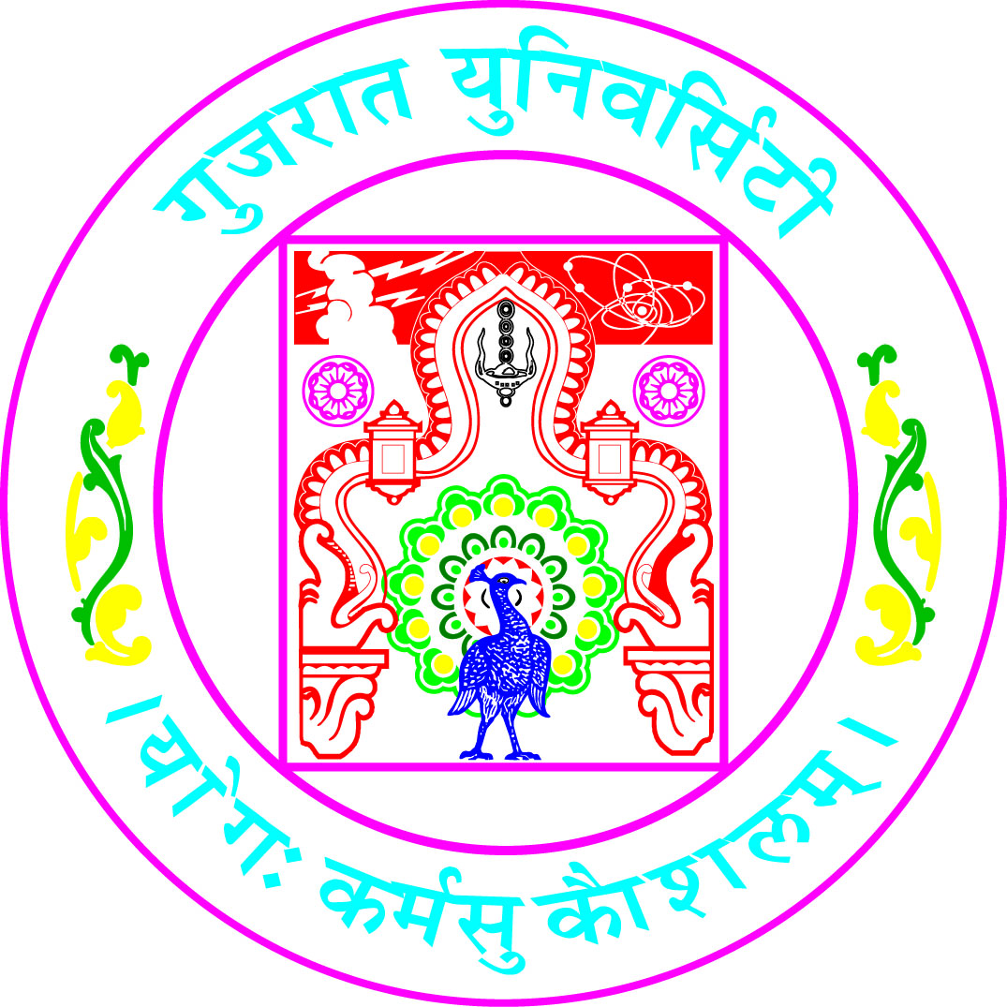

Certificate

Roll No : 03 Seat No :70002

This is to certify that Mr. /Ms. Janvi Chauhan student of Seventh Semester of 5 years Integrated M.Sc (Computer Science) has duly completed his/her project titled Department Grievance Management for the semester ending in December 2024, towards partial fulfillment of degree of 5 years Integrated M.Sc (Computer Science).

19/12/2024
Date of Submission Internal Project Guide
Dr. Hiren Joshi
Course Coordinator
Dr. Jyoti Pareek
Head of Department
Dr. Hiren Joshi

